HI All
Nice attendance and meeting, (with somewhat iffy weather), of about 33-35 happy fly tyers. The club is missing Roger’s mandatory sign in sheet, if you did not sign in, he did it for you. He is at home and recuperating, hope to see him soon.
Thanks to the tyers:
Russ Ahlgren with the Mouse Pattern, John Troiano and the Wood River Special, Ray Stevens instructing a Vinyl Rib Green Caddis, John McCall and his expertise with Soft Hackle, the still new and busy father, Alex Petti and his Flat Wing version, also for his frequent donations from Fin and Feather to the club, and Ed Lombardo with his Craft Fur Downwing.
I apologize, as I forgot to bring the two (2) Angelo Mangili rods that will be silent auctioned until May, so there is still plenty of time. The club still has the chest of fly drawers including many flies now at the low price of $40.00, look for them next month.
Speaking of next month, the tyers will be: Peter Burgess-salt, Mike Lombardo-fresh, Scott Travers-fresh, Ron Marafioti- fresh, Glen Northrup-salt, and Russ Alhgren- salt, (good to have Russ back in the fold!)
The grand winners for the buckets are:
Ann G, who again returned her winnings to be drawn again, John Mc, Dave P, Gus P and Alex P, who luckily did not win a Bears Den gift certificate again, and who donated his winning bucket to Maggie G.
Joke of the month: Did you hear about the crab who went to a seafood disco?
He pulled a mussel.
A thank you to Brad Buzzi of buzz@buzfly.com for his donation of a roll of Bill’s Bodi-Braid. Stop by and by some great buck tails next year at The Fly Fishing Show.

Thank you to Annmarie for her donation of many books and flyes. The salt water flyes will be made available for the members.
There will be a transition on the executive board for next year. Vice President Russ Ahlgren will be leaving as well as myself. There is room on the Board as well. The floor will be open for nominations in the spring.
The Bears Den Fly Fishing Show is February 22, 2020, and Peter B, John M and myself will be representing UFTRI. Anyone else interested in helping, please see a one of us.
We are in the midst of the inclement weather season, when in doubt, keep an eye on the web page, call a BOD (phone numbers under the tab), or call the KOC (401 737 9887), I will not hesitate to cancel a meeting to keep everyone safe.
Thanks and see you February 5th.
Jeff

Table 1
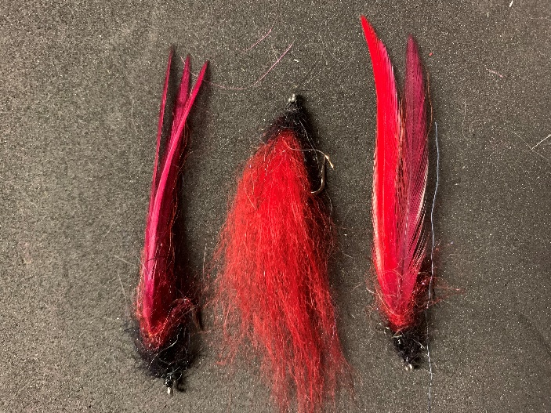
Glen Northrup
Flat Wing Worm
An effective pattern for a subtle presentation
Hook: short shank 2-6
Thread: 3/0 black, flat wax nylon
Body: Reddish Brown Bucktail, under 2 to 4 saddle hackles of various shades of red
Dubbing: Maybe some Sanyo red laser
Head: Black chenille or black polar dub and seal fur

Table 2
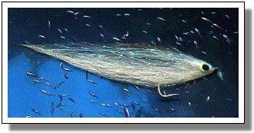
Russ Ahlgren
Gartside Blueback Herring

Hook: Mustad 34007, Daiichi 2546, #1/0
Thread: Danville’s 3/0, white
Tailwing: White bucktail
Flash: GSS or Flashabou
Underwing: White bucktail
Overwing: White bucktail with a topping of blue bucktail
Pattern from Jack Gartside archive
https://www.jackgartside.com/step_blueback_herring.htm
Atlantic herring spawn throughout most of the fishing season, usually from April through September, depending on locality, and are fed upon eagerly by many larger fish, including stripers. The blueback herring is one of the more commonly-found herrings. A good herring imitation should, therefore, be part of any salt water angler’s arsenal.
The Gartside Blueback Herring, described below, is a variation of the Bucktail Beauty (see my book Original Salt Water Fly Patterns for detailed tying instructions). The Bucktail Beauty (and the fly may also be tied in this manner) is constructed with three separate clumps of bucktail, one clump each for the tailwing, overwing and underwing (total length to be approximately 4 1/2”-6/”). You can also think of this type of construction as a Bucktail Deceiver, to which it is structurally similar or as a Blonde with an underwing.
The Gartside Blueback Herring is simply a blue/white Bucktail Beauty with a head of GSS fronting the fly to give it a more realistic appearance. Eyes are then painted on with fabric paint to complete the illusion. Another version of the Blueback Herring that I tie is tied completely with GSS but I'll leave the description of this fly for another time. Meanwhile, tie up a few of these to use next time you go out fishing. If you fish in the Northeast you'll find this a useful pattern throughout most of the fishing season.

TABLE 3
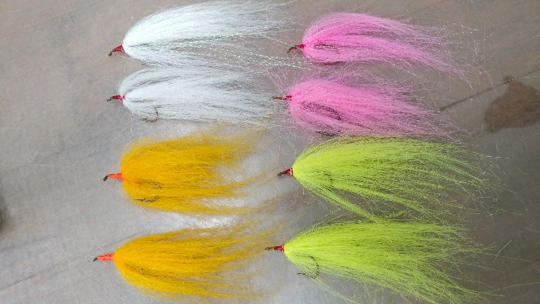

Ron’s Remote Water Ranger
Scott Travers
Streamer hook: stainless steel size 4 to 6
Thread: Red / Orange or other bright color waxed nylon
Body: Craft fur in pink, white, yellow, orange, chartreuse, etc.
Crystal flash: to match the craft fur color being used
Instructions: Mash Barb on Hook (for fresh water applications)
Secure Hook in Vice
Begin wrapping thread around shank of hook approximately one eye’s distance back from the eye of the hook
Wrap to about half way to the point of the hook
Trim off the tag end of the thread
Cut off a pencil sized clump of craft fur from the sheet
Pull out the short fibers
Tie in the cut end of the clump of craft fur on top of the shank so the tips of the fibers extend over the bend
Wrap the thread to behind the eye of the hook to begin forming the head of the fly
Return the thread to half way to the point of the hook
Select up to 5 strands of crystal flash
Tie in the middle of the strands on top of the shank of the hook
Separate each half of the strands of crystal flash so they stay on each side of the shank extending toward the bend
Take several wraps of thread back to secure the crystal flash on each side
Cut off a clump of craft fur from the sheet a little smaller than the pencil sized clump
Pull out the short fibers
Tie in the cut end of the clump of craft fur on top of the shank so the tips of the fibers extend over the eye
(This is reverse the direction in which we tied the first clump of craft fur)
If you have a rotary style tying vice invert the hook
If you do not have a rotary style tying vice remove the hook from the jaws of the vice
Rotate the hook 180 degrees so that it is upside down
Secure hook back in the tying vice upside down
Cut off a clump of craft fur from the sheet a little smaller than the pencil sized clump
Pull out the short fibers
Tie in the cut end of the clump of craft fur on top (really the bottom) of the shank so the tips extend over the eye
If you have a rotary style tying vice invert the hook again so that it is right side up
If you do not have a rotary style tying vice remove the hook from the jaws of the vice
Rotate the hook 180 degrees so that it is right side up again
Secure hook back in the vice
Fold the top and bottom sections of craft fur that extend over the eye back so that they extend over the bend
Tie all sections so they extend over the bend
Build up head of the fly with thread so that fly ends up with a nice, tapered head
Tie off thread
Apply head cement
Cut off thread
Go catch some fish!

Table 4
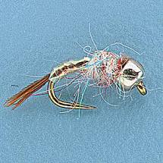
Mike Lombardo
Rainbow Warrior
Two years ago I fished Mirror Lake in Utah. There I met a fellow and his wife who were dolng very well nymph fishing. Fortunately, they offered me a sample of the fly that was so productive, the Rainbow Warrior. A few minutes later, I caught my first Tiger Trout, and I became a believer. This fly was designed by Lance Egan, a member of the men’s USA Fly Fishing Team. Lance has caught fish on it from New Zeland to Alaska and throughout the west. It can be tied as a midge nymph in sizes eighteen through twenty-two and as a mayfly nymph in larger hook sizes.
Hook: 16 TMC 2457 heavy wire scud hook, 2x wide, 2x short
Bead: Tungsten 2.3 mm
Thread: UTC Red 70 denier
Tail: Ringneck pheasant tail
Under body: UTC Red 70 denier
Over body and wing case: Veevus wide ​pearl mylar tinsel or​ wide ​ pearl Flashabou
Thorax: Wapsi Scud Rainbow Dubbing​ is recommended.
Hot spot collar: red thread

Table 5

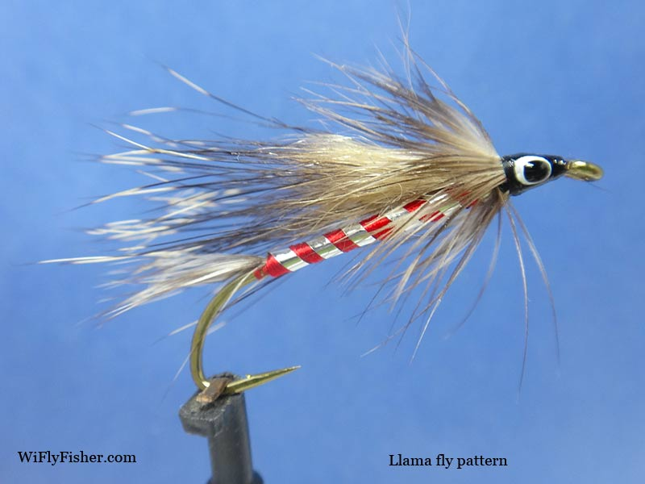
Llama
Ron Marafioti
June/July 1973 Fly Fisherman magazine story titled "Tying the Llama and Why" by Eric Leiser. Although Eric is responsible for popularizing the pattern he first got the pattern from Ray Benedict who used it frequently on the Wolf River and supposedly Miles Tourellot, a Wisconsin Menominee Indian originated the fly pattern back in the 1940s. It is said Miles found the pattern listed in an old English fly pattern book. Mike Valla also wrote about the Llama pattern and Eric Leiser recently in his book called "Tying The Founding Flies", published in 2015. Llama Fly Pattern (Original Recipe) tied by John Simonson
Materials:
Hook: Mustad 3665A
Thread: black Tail: Grizzly Hackle fibers (soft)
Rib: Flat silver tinsel
Body: 4 strands red floss [for the Fireside Angler, or 4 strands of yellow floss for the Llama]
Wing: Woodchuck hair, leave guard hairs & underfur
Collar: Grizzly hackle (soft)
Head: Black thread with painted [or stick-on] eyes
Adhesive: Sally Hansen’s Hard as Nails
There are many variations to this old fly pattern by changing the floss color and using gold tinsel.

Table 6
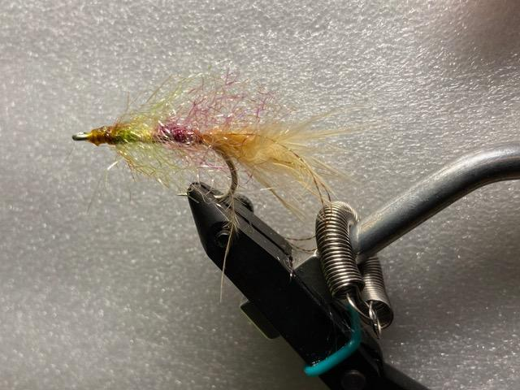

El Shrimpo
Peter Burgess
(This is the designed by Ed Lombardo)
Hook: mustard 3407
Thread: 6/0 pick your own color
Material: aura yarn and tan marabou

